VIETNAM GENERAL CONFEDERATION OF LABOR
TON DUC THANG UNIVERSITY
FACULTY OF INFORMATION TECHNOLOGY



NGUYEN ANH QUAN – 523H0083
NGUYEN THI ANH THU – 523H0101

FINAL REPORT

PRODUCTION-GRADE CI/CD SYSTEM

SOFTWARE DEPLOYMENT, OPERATIONS AND MAINTENANCE

HO CHI MINH CITY, 2026
VIETNAM GENERAL CONFEDERATION OF LABOR
TON DUC THANG UNIVERSITY
FACULTY OF INFORMATION TECHNOLOGY



NGUYEN ANH QUAN – 523H0083
NGUYEN THI ANH THU – 523H0101

MIDTERM REPORT

PRODUCTION-GRADE CI/CD SYSTEM

SOFTWARE DEPLOYMENT, OPERATIONS AND MAINTENANCE

Advised by
M.S. Mai Van Manh

HO CHI MINH CITY, 2026
ACKNOWLEDGEMENT

We would like to express our sincere gratitude to Mr. Mai Van Manh, our instructor and mentor, for his valuable guidance and support throughout the mid-term report of our project on Production-Grade CI/CD System. He has been very helpful and patient in providing us with constructive feedback and suggestions to improve our work. He has also encouraged us to explore new technologies and techniques to enhance our system's functionality and performance. We have learned a lot from his expertise and experience in web development and software engineering. We are honored and privileged to have him as our teacher and supervisor.

Ho Chi Minh City, 3rd May 2026.
Author
(Signature and full name)

Quan
Nguyen Anh Quan

Thu
Nguyen Thi Anh Thu

DECLARATION OF AUTHORSHIP
We hereby declare that this is our own project and is guided by Mr. Mai Van Manh; The content research and results contained herein are central and have not been published in any form before. The data in the tables for analysis, comments, and evaluation are collected by the main author from different sources, which are clearly stated in the reference section.
In addition, the project also uses some comments, assessments, as well as data from other authors and other organizations, with citations and annotated sources.
If something goes wrong, we’ll take full responsibility for the content of my project. Ton Duc Thang University is not related to the infringing rights, the copyrights that we give during the implementation process (if any).
Ho Chi Minh City, 3rd May 2026
Author
(Signature and full name)

Quan
Nguyen Anh Quan

Thu
Nguyen Thi Anh Thu

TABLE OF CONTENTS
TABLE OF CONTENTS iii
TABLE OF FIGURE iv
CHAPTER 1. OVERVIEW & SYSTEM ARCHITECTURE 1
1.1 Introduction and Background 1
1.2 Architecture Tier Selection 1
1.3 System Architecture Overview 1
1.4 Technology Stack 2
1.5 End-to-End Flow 3
CHAPTER 2. INFRASTRUCTURE PROVISIONING 3
2.1 Infrastructure as Code Approach 3
2.2 Terraform Resource Provisioning 4
2.3 Ansible Configuration Management 5
2.4 Domain, DNS, and HTTPS Configuration 6
CHAPTER 3. CI/CD PIPELINE DESIGN 7
3.1 Pipeline Overview 7
3.2 Continuous Integration (CI) 7
3.2.1 Dependency Caching 7
3.2.2 Security Scanning with Trivy 8
3.2.3 Versioning Strategy 8
3.3 Continuous Delivery (CD) 8
3.4 Rolling Update Strategy 8
3.5 GitHub Secrets Management 9
CHAPTER 4. DEPLOYMENT & ORCHESTRATION 9
4.1 Docker Swarm Architecture 9
4.2 Service Definitions 10
4.2.1 Web Application Service 10
4.2.2 Monitoring Services (Global Mode) 10
4.3 Dockerfile Design 10
4.4 MongoDB Persistence 11
4.5 Horizontal Scaling and Fault Tolerance 11
CHAPTER 5. MONITORING, OBSERVABILITY & LESSONS LEARNED 11
5.1 Monitoring Architecture 11
5.2 Prometheus Configuration 12
5.3 Grafana Dashboards 12
5.4 Observability During Deployment 13
5.5 Challenges and Solutions 13
5.6 Lessons Learned 14
5.7 Future Improvements 14

TABLE OF FIGURE
No table of figures entries found.

OVERVIEW & SYSTEM ARCHITECTURE

Introduction and Background
This report documents the design, implementation, and deployment of a production-grade CI/CD system for the Final Exam Project of the Software Deployment, Operations & Maintenance course. The project simulates a real-world DevOps scenario in which a rapidly growing startup — referred to as 'Startup X' — requires its engineering team to standardise and harden the entire software delivery process.
The existing system, developed during the midterm project, lacked several critical enterprise-level capabilities: end-to-end automation from source code to production, integrated security throughout the deployment lifecycle, horizontal scalability, and comprehensive observability. This project addresses all of these gaps by implementing a fully automated, observable, and resilient deployment pipeline.

Architecture Tier Selection
The team selected Tier 4 — Docker Swarm-Based Orchestration — as the deployment architecture for this project. This decision was based on the following rationale:
- Tier 4 provides cluster-level scheduling, service replication, and fault tolerance capabilities that are not available in lower tiers.
- Docker Swarm offers a balance between orchestration complexity and operational manageability compared to Kubernetes (Tier 5).
- The team's proficiency with Docker Compose from the midterm project provided a solid foundation for transitioning to Swarm.
- Tier 4 enables the maximum architecture score of 2.5 points, reflecting the team's technical ambition.

System Architecture Overview
The production system is deployed on AWS Academy and consists of three Ubuntu EC2 instances organised as follows:
Component | Description
App Server 1 (Manager) | Docker Swarm Manager node. Runs web application replicas, node-exporter, cAdvisor, and automated Dynamic DNS (DDNS) synchronization logic.  Private IP: 172.31.36.207
App Server 2 (Worker) | Docker Swarm Worker node. Runs web application replicas, node-exporter, and cAdvisor.  Private IP: 172.31.35.211
DB + Monitoring Server | Runs MongoDB database, Prometheus, and Grafana. Private IP: 172.31.33.108
AWS ALB | Application Load Balancer distributing traffic across both app servers on port 3000
DuckDNS Domain | finalprojectdeloy.duckdns.org — public domain with HTTPS via Let's Encrypt
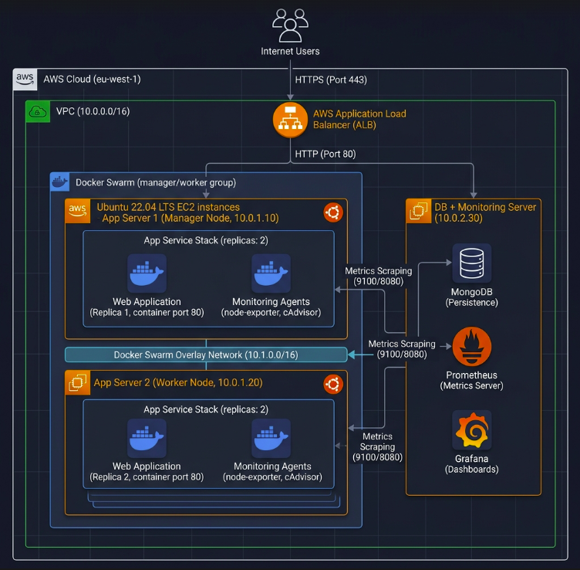

Technology Stack
Category | Technologies
Cloud Provider | AWS Academy (EC2 t2.micro, Application Load Balancer, VPC, Security Groups)
Infrastructure as Code | Terraform v6.x (resource provisioning), Ansible (configuration management)
Application | Node.js 20 + Express + EJS + Mongoose (MongoDB ODM)
Containerisation | Docker 29.x, Docker Swarm (cluster orchestration)
CI/CD | GitHub Actions (workflow automation)
Container Registry | Docker Hub
Security Scanning | Trivy (CVE scanning for Docker images)
Code Quality | ESLint (static analysis)
Database | MongoDB 6.0 (with Docker persistent volumes)
Monitoring | Prometheus + Grafana + node-exporter + cAdvisor
DNS & HTTPS | DuckDNS (dynamic DNS), Let's Encrypt + Certbot (TLS certificates), Automated IP Synchronization (Ansible-provisioned cron jobs).
Reverse Proxy | Nginx (HTTPS termination, HTTP-to-HTTPS redirect)

End-to-End Flow
(0) Upon AWS Academy instance restart, the infrastructure automatically self-heals by synchronizing the new Public IP with the DuckDNS domain via a pre-configured crontab script.
- Developer pushes code to the main branch on GitHub.
- GitHub Actions CI pipeline triggers automatically: lint → test → build Docker image → Trivy security scan → push image to Docker Hub with commit SHA tag.
- GitHub Actions CD pipeline deploys using docker service update with rolling update strategy on the Swarm cluster.
- Swarm Manager schedules updated replicas across Manager and Worker nodes.
- Production is accessible via https://finalprojectdeloy.duckdns.org with valid TLS certificate.
- Prometheus scrapes metrics from all nodes; Grafana dashboards reflect real-time system state.
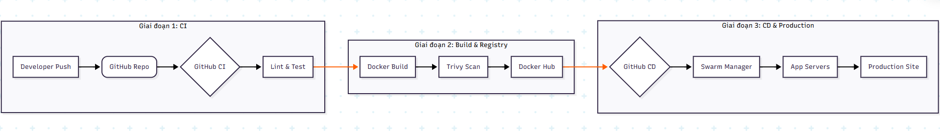

INFRASTRUCTURE PROVISIONING

Infrastructure as Code Approach
The team adopted a full Infrastructure as Code (IaC) approach using Terraform for resource provisioning and Ansible for system configuration. This approach was chosen over manual provisioning for the following reasons:
- Idempotency: repeated execution produces consistent results without unintended side effects.
- Reproducibility: the entire infrastructure can be rebuilt from code in minutes.
- Documentation as code: the infrastructure definition serves as living documentation.
- Version control: all infrastructure changes are tracked in Git.

Terraform Resource Provisioning
Terraform provisions the following AWS resources:
- Two EC2 t2.micro instances for app servers (app-server-1 as Swarm Manager, app-server-2 as Swarm Worker)
- One EC2 t2.micro instance for the DB and monitoring server
- Two Security Groups: final-project-app-sg (ports 22, 80, 443, 3000, 8080, 9100) and final-project-db-sg (ports 22, 27017, 9090, 3001, 80, 443)
- AWS Application Load Balancer (final-project-alb) with target group and HTTP listener
- Target group attachments linking both app servers to the ALB
Key Terraform configuration:
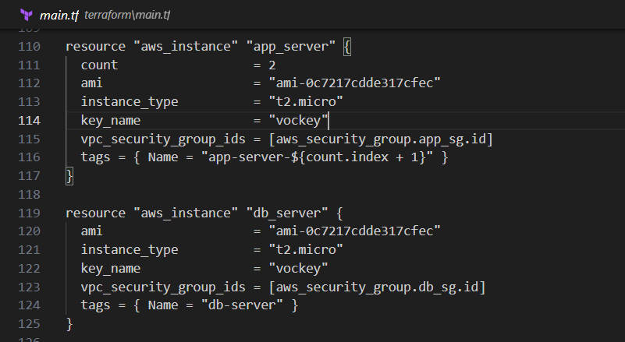
Figure 2.1 Terraform configuration for Target Group
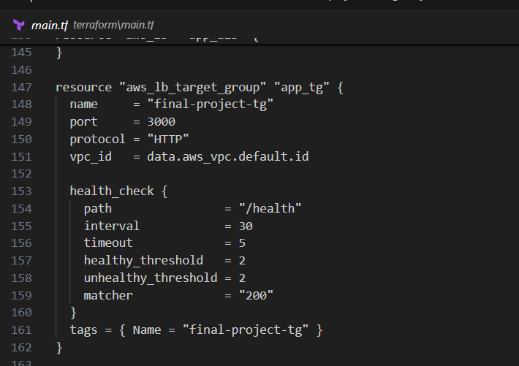
Figure 2.2 Health check monitoring

Idempotency Evidence
Running terraform apply a second time produces: 'No changes. Your infrastructure matches the configuration. Apply complete! Resources: 0 added, 0 changed, 0 destroyed.' This confirms full idempotency.

Ansible Configuration Management
Ansible configures all three servers after Terraform provisioning. The playbook is structured into two plays:
- Play 1 — App Servers: installs Docker, Docker Compose, Nginx, Certbot, Git, curl; starts and enables Docker and Nginx; adds ubuntu to the docker group; creates the application directory.
- Play 2 — DB Server: installs Docker and Docker Compose; creates db and monitoring directories; writes prometheus.yml with all scrape targets using private IPs; restarts Prometheus to load the new configuration.
Private IPs are used throughout the Ansible configuration to ensure stability across AWS Academy lab restarts, as private IPs remain constant while public IPs change.
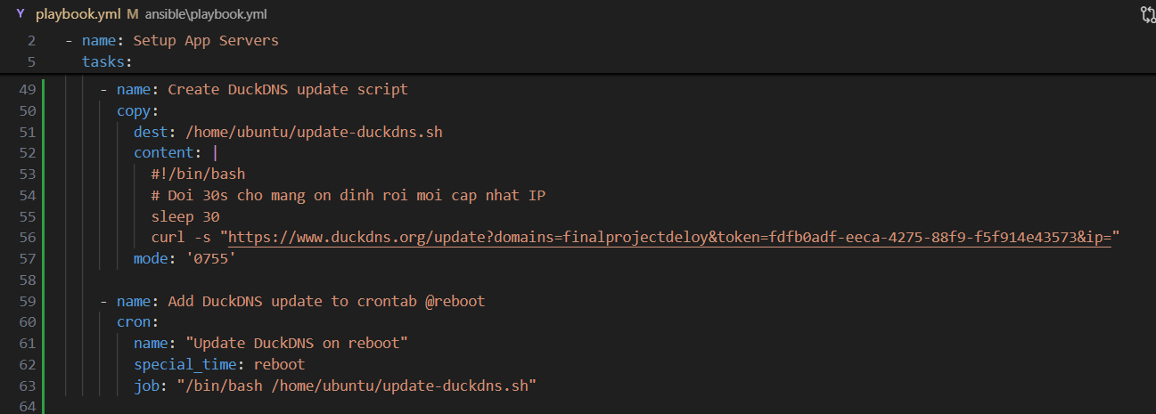
Figure 2.3 ansible/playbook.yml.create DuckDNS update script
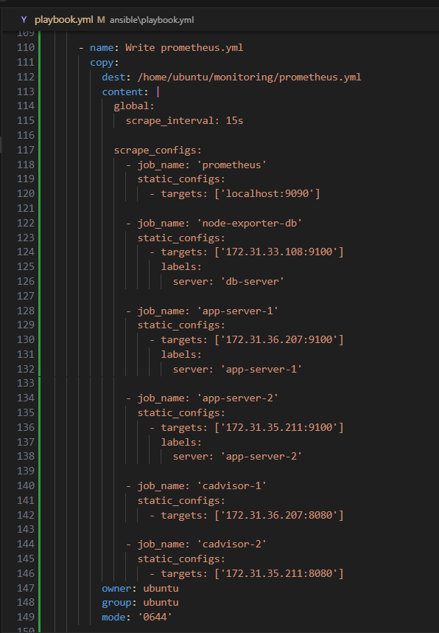
Figure 2.4 ansible/playbook.yml write prometheus.yml
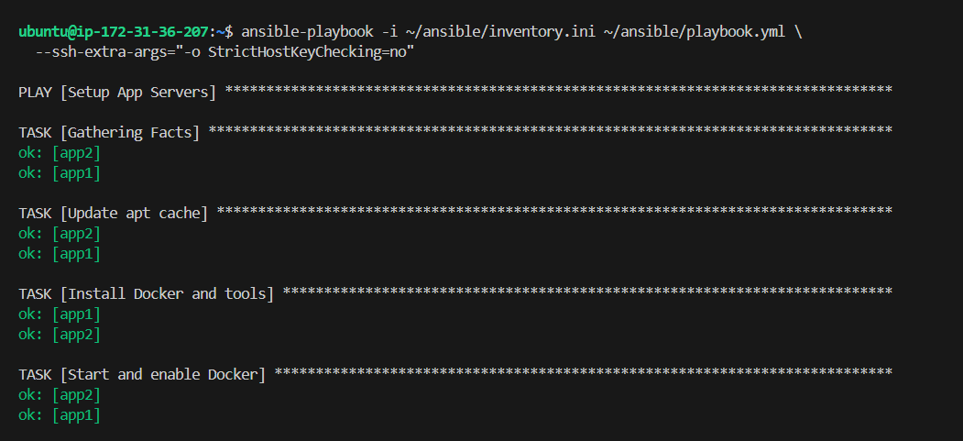
Figure 2.5 Run ansible/playbook.yml.
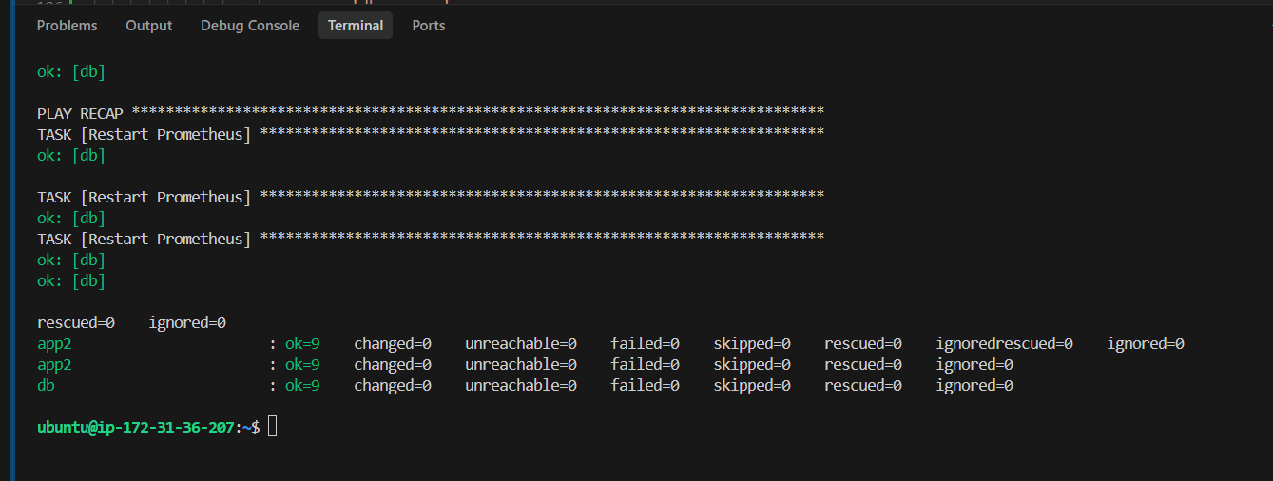
Figure 2.6 Play recap ansible/playbook.yml.

The full Ansible playbook containing 150+ lines of configuration is available in the project repository under ansible/playbook.yml.

Domain, DNS, and HTTPS Configuration
DNS is managed through DuckDNS, a free dynamic DNS service. The domain finalprojectdeloy.duckdns.org is configured with an A record pointing to the App Server 1 public IP address.
To ensure the domain always points to the correct public IP after AWS Academy restarts, a crontab entry is configured on App Server 1. This command is wrapped inside a shell script and executed automatically on every system reboot:
curl -s https://www.duckdns.org/update?domains=finalprojectdeloy&token=fdfb0adf-eeca-4275-88f9-f5f914e43573&ip=
HTTPS is configured on both app servers using Let's Encrypt certificates issued via Certbot. Nginx serves as the reverse proxy, terminating TLS and forwarding requests to the Node.js application on port 3000. HTTP traffic is automatically redirected to HTTPS.

CI/CD PIPELINE DESIGN

Pipeline Overview
The CI/CD pipeline is implemented using GitHub Actions and is defined in .github/workflows/ci.yml. The pipeline is divided into two jobs: ci (Continuous Integration) and deploy (Continuous Delivery). The deploy job depends on the ci job and only runs when a push is made to the main branch.
Stage | Purpose
Checkout | Retrieves the latest source code from the repository
Setup Node.js 20 | Configures the Node.js runtime with npm dependency caching
Install dependencies | Installs all packages including devDependencies for ESLint
Lint code | ESLint static analysis — pipeline fails on errors
Test | Runs unit tests to verify application correctness
Build Docker image | Builds image tagged with commit SHA (never 'latest')
Trivy security scan | Scans for CRITICAL/HIGH CVEs — continue-on-error: true
Login to Docker Hub | Authenticates using GitHub Secrets
Push to Docker Hub | Pushes both SHA-tagged and latest images
Deploy to Swarm | SSH to Manager node and runs docker service update

Continuous Integration (CI)
The CI stage executes automatically upon every push to main or pull request. Key design decisions are described below.

Dependency Caching
npm dependencies are cached using the cache: 'npm' option in the Setup Node.js action. The cache key is derived from the package-lock.json file hash, ensuring that cache is invalidated when dependencies change. This reduces build time significantly on subsequent runs.

Security Scanning with Trivy
Trivy scans the built Docker image for known CVEs at CRITICAL and HIGH severity levels. The pipeline uses continue-on-error: true to allow deployment to proceed while still recording vulnerability information. All detected CVEs are logged in the Actions output and must be documented in this report.

Versioning Strategy
Docker images are tagged with the Git commit SHA (github.sha). This ensures that every image is uniquely identifiable and traceable to its source commit. The 'latest' tag is also pushed for convenience but is never used in production deployments. Using commit SHA tags eliminates ambiguity about which code version is running in production.

Continuous Delivery (CD)
The CD stage deploys the validated image to the Docker Swarm cluster on the Manager node (App Server 1). The deployment uses docker service update with a rolling update configuration:
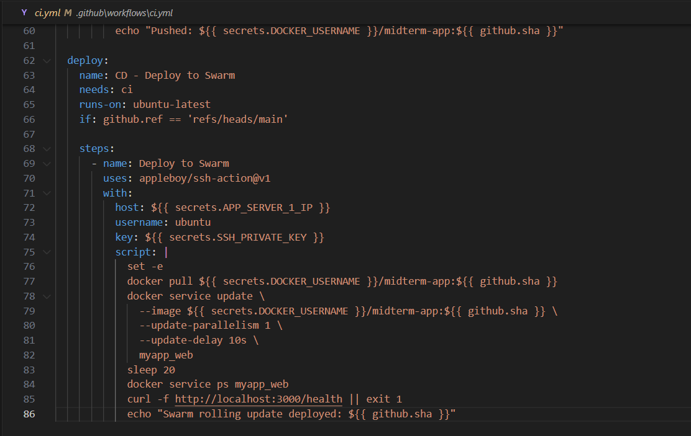

Rolling Update Strategy
The deployment uses a rolling update strategy with parallelism 1 and a 10-second delay between updates. This means one replica is updated at a time, with a brief pause between each update. This approach ensures zero downtime: while one replica is being updated, the other continues to serve traffic.
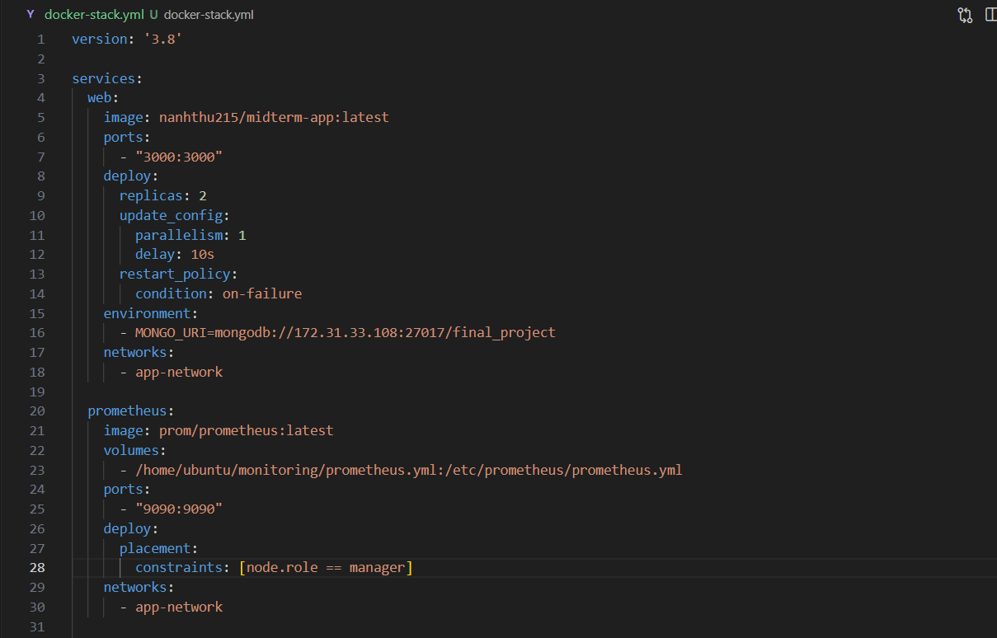
Figure 3.1 docker-stack.yml
Trade-off Analysis
Rolling updates provide zero downtime but introduce a brief period where different replica versions may be running simultaneously. For this application, this is acceptable as the API is stateless. For applications with strict version consistency requirements, a blue-green deployment would be more appropriate.

GitHub Secrets Management
Sensitive credentials are stored as GitHub Actions repository secrets and never hardcoded in any file. The following secrets are configured:

Secret | Purpose
DOCKER_USERNAME | Docker Hub account username
DOCKER_PASSWORD | Docker Hub personal access token
SSH_PRIVATE_KEY | RSA private key for SSH access to EC2 instances
APP_SERVER_1_IP | Public IP of App Server 1 (updated automatically via update_ips.bat)
APP_SERVER_2_IP | Public IP of App Server 2 (updated automatically via update_ips.bat)

DEPLOYMENT & ORCHESTRATION

Docker Swarm Architecture
Docker Swarm provides cluster-level orchestration for the application. The cluster consists of two nodes:
- Manager Node (ip-172-31-36-207): Responsible for cluster management, service scheduling, and accepting API commands. Also runs application workloads.
- Worker Node (ip-172-31-35-211): Executes tasks assigned by the Manager. Runs application workloads.
The Swarm cluster is initialised on App Server 1 using the private IP address to ensure stable inter-node communication that persists across lab restarts:

Service Definitions
Three services are defined in the Docker Swarm stack file (docker-stack.yml):

Web Application Service
The web service runs the Node.js application with 2 replicas distributed across both nodes. Key configuration includes:
- replicas: 2 — ensures one replica on each node for high availability
- update_config: parallelism 1, delay 10s, order start-first — rolling update with zero downtime
- restart_policy: on-failure — automatically restarts failed containers
- MONGO_URI points to the DB server's private IP (172.31.33.108) for stable connectivity

Monitoring Services (Global Mode)
Both node-exporter and cAdvisor are deployed in global mode, meaning exactly one instance runs on every node in the Swarm cluster. Port binding uses mode: host to ensure metrics are accessible on each node's IP address for Prometheus scraping:
- node-exporter: collects host-level metrics (CPU, memory, disk, network) on port 9100
- cAdvisor: collects container-level metrics on port 8080

Dockerfile Design
The Dockerfile uses a multi-stage build pattern to produce a minimal production image:

Design decisions: node:20-alpine is used as the base image to minimise attack surface and image size. The HEALTHCHECK instruction enables Docker Swarm to monitor container health and automatically restart unhealthy containers.

MongoDB Persistence
MongoDB runs on the dedicated DB server with a Docker named volume (mongo_data) mounted at /data/db. Named volumes persist data independently of the container lifecycle, ensuring that database content survives container restarts, updates, and redeployments.

Horizontal Scaling and Fault Tolerance
The Swarm deployment demonstrates horizontal scaling and fault tolerance as follows:
- Scale-out: additional replicas can be added with docker service scale myapp_web=N without downtime.
- Self-healing: when a container fails (e.g., is killed), Swarm automatically schedules a replacement replica on an available node within seconds.
- Load distribution: the two web replicas are distributed across Manager and Worker nodes, distributing both compute load and failure risk.
Failure Simulation Result
When a web container is killed using 'docker kill CONTAINER_ID', Docker Swarm detects the failure within approximately 5 seconds and schedules a new replica. The service remains accessible throughout the failure and recovery because the second replica continues serving traffic. This behaviour is confirmed by the 'task: non-zero exit' entries in docker service ps output followed immediately by a new Running task.

MONITORING, OBSERVABILITY & LESSONS LEARNED

Monitoring Architecture
The monitoring stack consists of Prometheus for metrics collection and Grafana for visualisation, deployed on the dedicated DB server. The architecture follows the standard pull-based model where Prometheus scrapes metrics endpoints exposed by exporters on each monitored node.
Component | Role
Prometheus | Scrapes metrics from all targets every 15 seconds; stores time-series data
Grafana | Visualises metrics via pre-built dashboards; connects to Prometheus as datasource
node-exporter | Exposes host-level metrics (CPU, memory, disk, network) on port 9100
cAdvisor | Exposes container-level metrics (per-container CPU, memory, network) on port 8080

Prometheus Configuration
Prometheus is configured to scrape six targets using private IP addresses, which remain stable across AWS Academy lab restarts. Private IPs are critical here: using public IPs would require updating the configuration after every lab restart.

The prometheus.yml file is managed by Ansible (Write prometheus.yml task) ensuring it is always correct and consistent across restarts. This is a key example of configuration-as-code applied to the monitoring layer.

Grafana Dashboards
Two dashboards are configured in Grafana:
- Node Exporter Full (ID: 1860): displays CPU usage, memory usage, disk I/O, and network traffic for each app server. The Job and Instance dropdowns allow switching between app-server-1 and app-server-2.
- Docker and System Monitoring (ID: 893): displays container-level metrics including container count, CPU usage per container, and network traffic per container.

Dashboards are exported as JSON and included in the submission for reproducibility. The Prometheus datasource is configured with the internal Docker network address (http://prometheus:9090) to ensure connectivity within the monitoring Docker Compose network.

Observability During Deployment
Monitoring is actively used during the deployment demonstration to provide evidence of system behaviour:
- During rolling update: CPU usage briefly spikes as new containers start and old ones drain.
- During failure simulation: container count metric drops immediately when a container is killed, then recovers as Swarm reschedules the replacement.
- Normal operation: CPU usage remains below 5% and memory usage below 60% for t2.micro instances under typical load.

Challenges and Solutions
Challenge | Solution
AWS Academy public IPs change on every lab restart | Used private IPs (stable) in all internal configurations (Ansible inventory, Prometheus scrape targets, Swarm advertise-addr). Created update_ips.bat script and DuckDNS crontab for automatic public IP updates.
Docker Swarm port binding in global services | Switched from default ingress port mode to host mode (mode: host) for node-exporter and cAdvisor to ensure ports are bound directly on each host, making them reachable via node IP.
ESLint v10 config format change | Migrated from .eslintrc.json to eslint.config.mjs (ESM format) required by ESLint v9+. Added ignores for browser-side JavaScript files to prevent false positives from browser globals.
docker-compose v1.29 incompatibility with new images | Replaced docker-compose up --no-deps with docker service update for Swarm deployments. Used docker stop/rm + docker run for standalone containers.
Trivy finding HIGH CVEs in base image | Documented CVEs in report with risk acceptance justification. Used continue-on-error: true in pipeline to allow deployment while maintaining security visibility.

Lessons Learned
Several important lessons emerged from this project:
- Private IPs over public IPs for internal communication: In cloud environments where public IPs change frequently, internal service communication must always use private/stable addresses. This applies to Swarm cluster communication, database connections, and monitoring scrape targets.
- IaC idempotency requires careful design: Achieving true idempotency in Ansible requires attention to module choice. Shell commands always report 'changed' unless changed_when: false is set. Using native Ansible modules (copy, file, systemd) instead of shell commands produces genuinely idempotent behaviour.
- Security scanning should fail fast but not block: Trivy security scanning with continue-on-error: true provides visibility into vulnerabilities without blocking deployments when CVEs are in base images outside team control. The key is to document and acknowledge CVEs rather than ignore them.
- Tier selection should match operational capability: While Tier 5 (Kubernetes) would provide greater functionality, Tier 4 (Docker Swarm) was the right choice given the team size and time constraints. A well-implemented lower tier consistently outperforms a poorly implemented higher tier.

Future Improvements
Implement Alertmanager for automated alerting on metric thresholds (e.g., CPU > 80%, container down).
Add centralised logging with Loki or ELK Stack for log aggregation across all nodes.
Implement staging environment with manual approval gate before production deployment.
Add automated rollback triggered by failed health checks after deployment.
Consider migrating to Kubernetes (Tier 5) for production workloads requiring more sophisticated autoscaling.

